**OLIVER NJIRU NJERU 663565**

* *Save the Jobs table and screen-capture both its structure and data and paste into word.*

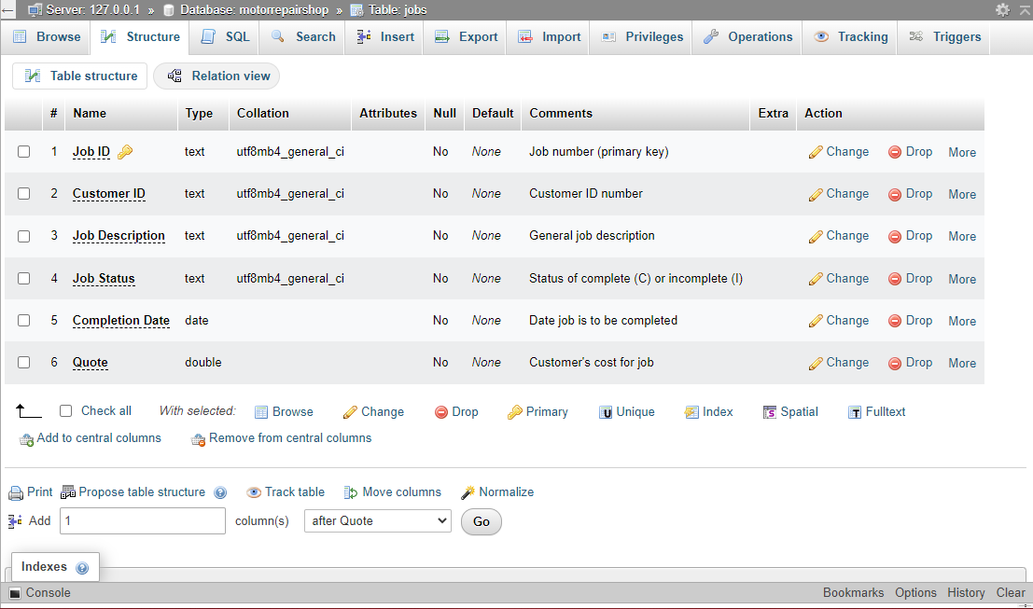

* *Save the Jobs table and screen-capture both its structure and data and paste into word.*

* *Save the Customer table and screen-capture both its structure and data and paste into word.*

* *Save the Customer table and screen-capture both its structure and data and paste into word.*

* Now add one record in the Customer table with your name and your particulars – this is mandatory.

1. Open the Repair Shop database and then open the Jobs table in Design view.

2. Create a single field index for the Customer ID field, allowing for duplicates.

3. Create a multiple field index using the Customer ID and the Job Description fields. Name this index CustIDDesc.

4. Save these changes and display the Jobs table in browse view.

5. Order the records in the Jobs table in ascending sequence by Job Description within Customer ID.

8. Add a field called Quote Date between the Completion Date and Quote fields. Define the field as Date/Time. This field will contain the date the quoted price was given.

9. Save these changes and display the Jobs table in Browser view.

10. Change the Job Description for Job ID A564 from Valve Job – 66 Falcon to Rebuild Trans – 61 Thunderbird.

11. Order the records by the Job Description within Customer ID.

12. Create and save the following validation rules for the Jobs table:

a. Assign a default value of I to the Job Status field.

b. Make Customer ID a required field.

c. Specify that the values for Quote must be greater than or equal to 100 and less than or equal to 10000.

